

GROUP MEMBERS :

TALHA RIZWAN I190652

MUHAMMAD IBTISAM I190422

ANSER QURESHI I190680

**DB lab project report**

**DESCRIPTION**

**STEP-BY-STEP PROCEDURE:**

The procedure of interface is all according to the requirements of FIT-ME. The user first registers himself in the database from the registration form if he is not already registered, this creates his record to the database . Then the user enters his login username and password and get access to the next page i-e the main menu. In main menu, the user can enter his daily diet plan in the diet plan form, can enter his nutrition record in his nutrition plan, can enter his exercise record in the exercise chart and can also generate his workout plan. The FIT-ME has four reports which show reports for different aspects of FIT-ME. The first report shows the records of the diet plans of the members in a decent manner. The second report displays the exercise plan of all the registered members of the gym. The third report shows the report for all the workout plans of different members. Last report shows the data of all the registered members and the necessary information about them. All these forms and reports have access from the buttons in the main menu and they return back to the main menu via buttons in each page.

**ERD (ENTITY RELATION DIAGRAM):**

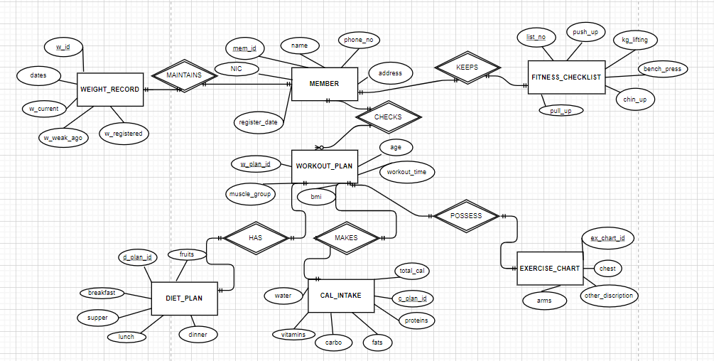Below is the entity relation diagram for the FIT-ME database system according to the requirements.

**TABLE DESCRIPTION:**

**MEMBER:**

* The member table in the database is for keeping the record of the biodata of the members.

**Weight_record:**

* The weight record table keeps the record of members weight related information.
* This table has the primary key of member table as foreign key.

**Fitness_checklist:**

* The fitness checklist table keeps the daily fitness records of the member.
* This table has the primary key of member table as foreign key.

**Workout_plan**

* The workout plan table keeps the record of different physical records of the member e.g. bmi , muscle record.
* The workout plan has primary keys from four tables as foreign keys i-e from member , diet plan, Cal intake, exercise chart table.

**Exercise_chart**

* This table keeps the record of different exercises of member.
* This table’s primary key is placed in the workout table as foreign key.

**Diet_plan**

* This table keeps the record of diet intake by the member everyday.
* This table’s primary key is placed in the workout table as foreign key.

**Cal_intake**

* This table keeps the record of the daily calories’ intake of the registered members.
* This table’s primary key is placed in the workout table as foreign key.

**SCHEMA DIAGRAM:**

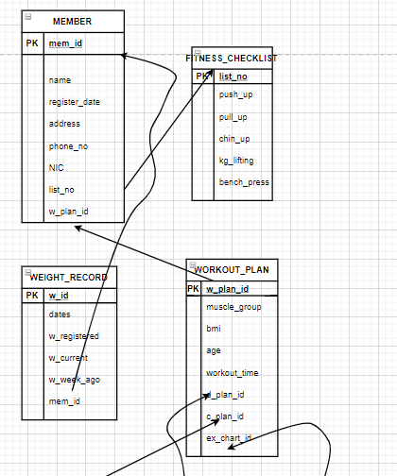

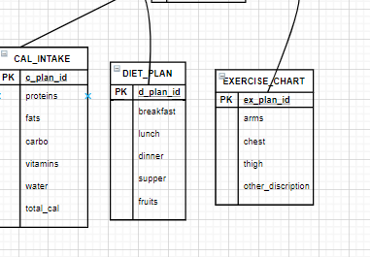

**SCREENSHOT OF THE INTERFACE:**







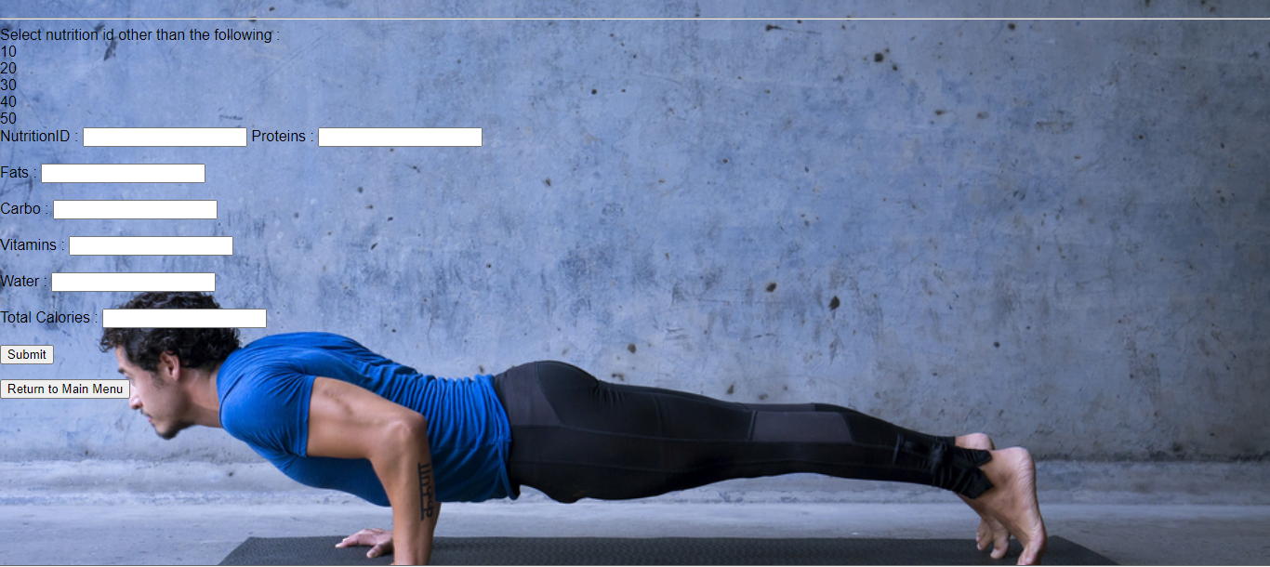

**The End**